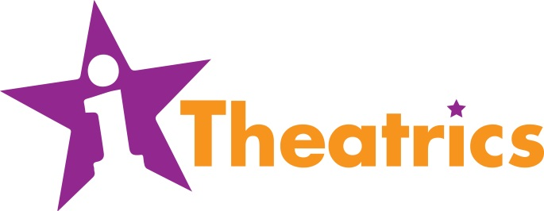
2020 Summer Workshop Scholarship Form

As a sign of our commitment to making quality arts programming available to everyone, iTheatrics offers a limited number of need-based scholarships. Due to the high demand for scholarships, students who receive them are expected to be on time and fully prepared for all rehearsals as well as be a positive behavior role model for other students. Failure to do so can result in the scholarship being revoked.

To be considered for a scholarship, please completely fill out this form.

STUDENT’S NAME: ___________________________________________________

PARENT’S NAME: ___________________________________________________

PARENT’S EMAIL: ___________________________________________________

Explain your current financial situation and need for a scholarship in detail.

________________________________________________________________________________________________________________________________________________________________________________________________________________________________________________________________________________________________________________________________________________________________________________________________________________________________________________________________________________________________________________________________________________________________________________________________________________________________________________________________________________________________________________________________________________________________________________________________________________________________________________________________________________________________________________________________________________________________________

