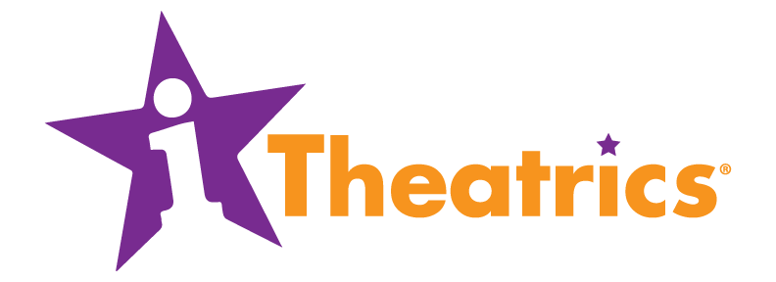

2020 SUMMER WORKSHOP AUDITION FORM

NAME: ______________________________________________________________

CURRENT GRADE: _______________ AGE: ___________________

CITY: __________________________ STATE: __________________

EMAIL: ______________________________________________________________

PARENT’S NAME: ____________________________________________________

PARENT’S EMAIL: ____________________________________________________

PHONE: _____________________________________________________________

WITH WHAT SCHOOL/ORGANIZATION DO YOU TYPICALLY PERFORM SHOWS?______________________________________________________________

Official titles will be announced when programming is finalized.

CHECK ALL WORKSHOP DATES FOR WHICH YOU ARE AVAILABLE
Please look closely at all workshop dates to make sure you don’t have any conflicts.

DATES | CAST AGES | YES | NO
Monday, July 6 - Friday, July 10 | Current grades 4-9
Monday, July 13 - Friday, July 17 | Current grades 4-9
Monday, July 20 - Thursday, July 30  (no rehearsals Saturday or Sunday) | Current grades 9-12
Monday, July 27 - Friday, July 31 | Current grades 4-9
Monday, August 10 - Friday, August 14 | Current grades 4-9

ARE YOU INTERESTED IN BEING CAST IN MORE THAN ONE WORKSHOP THIS SUMMER? YES NO

ARE YOU APPLYING FOR A SCHOLARSHIP? YES NO

If yes, all scholarship forms must be submitted at the auditions on February 29th or by March 1st if you are auditioning by video.

